- Question 1: Write a program to declare and print an integer variable.
import java.io.*;
class p1{
public static void main(String [] args){
int a =10;
System.out.println("Enter a integer value of :"+a);
}
}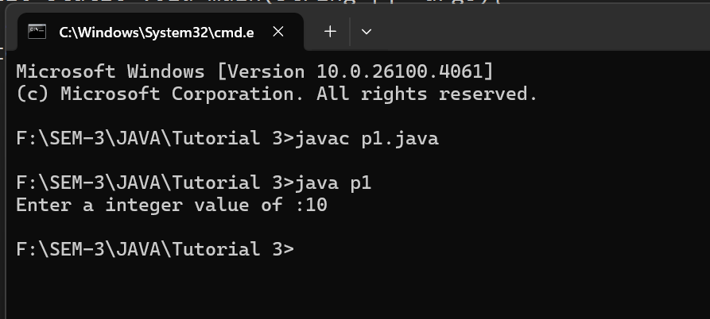

- Question 2: Write a program to declare and print a float variable.
import java.io.*;
class p2{
public static void main(String [] args){
float a =10.21f;
System.out.println("Enter a integer value of :"+a);
} }
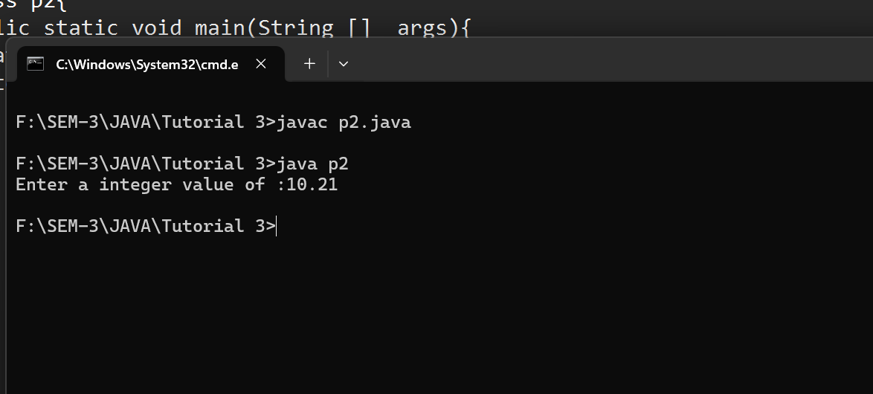

- Question 3: Write a program to declare and print a double variable.
import java.io.*;
class p3{
public static void main(String [] args){
double a =10.21;
System.out.println("Enter a double variable :"+a);
}
}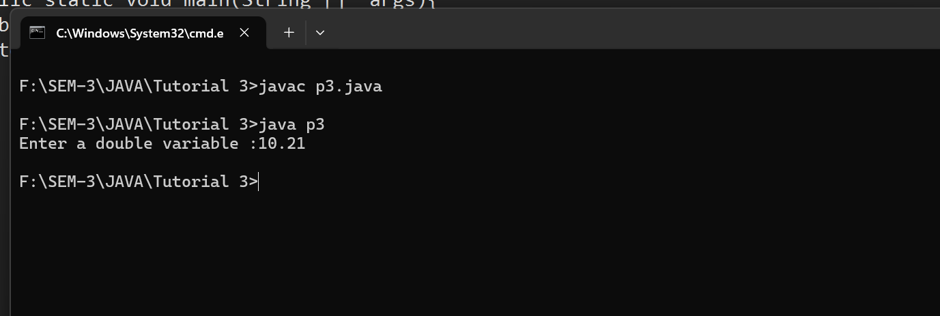

- Question 4: Write a program to declare and print a character variable.
import java.io.*;
class p4{
public static void main(String[] args) {
char myChar = 'N';

System.out.println("The character is: " + myChar);
}
}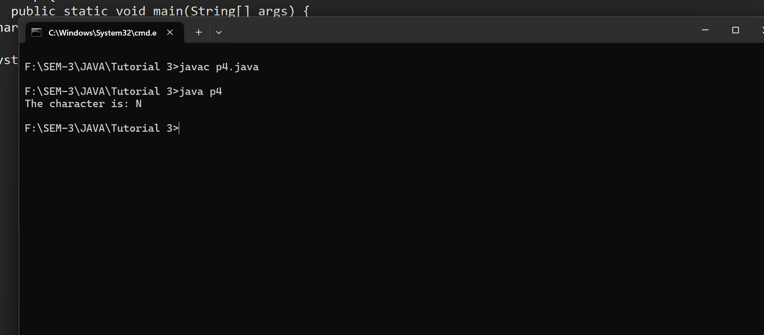

- Question 5: Write a program to declare and print a boolean variable.
public class BD{

public static void main(String[] args) {
boolean isActive = true;
System.out.println("The value of isActive is: " + isActive);
boolean isComplete = false;
System.out.println("The value of isComplete is: " + isComplete);
}
}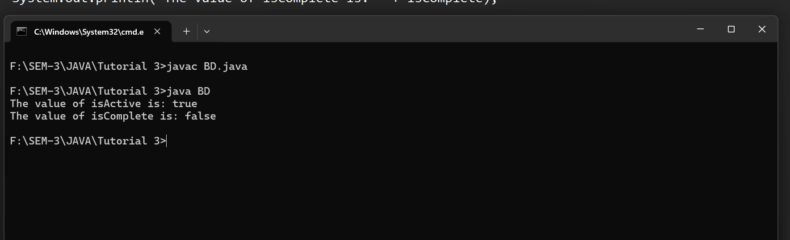

- Question 6: Write a program to add two integers and print the result.
import java .io.*;
import java.util.Scanner;
class AddTwoNum {
public static void main(String[] args) {
int a,b,sum;
Scanner sc = new Scanner(System.in);
System.out.println("Enter a Number of A:");
a = sc.nextInt();
System.out.println("Enter a Number of B:");
b = sc.nextInt();
sum = a+b;
System.out.println("The sum of :" + a + " and " + b + " is: " +sum);
}
}
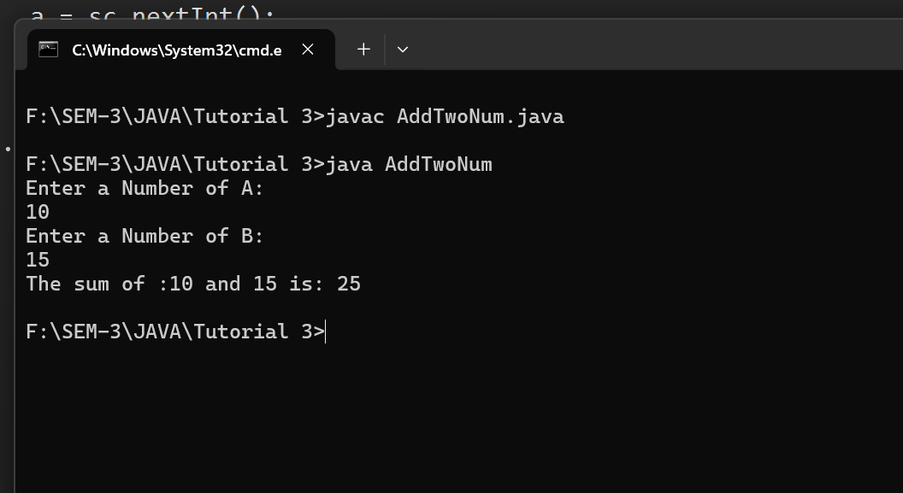

- Question 7:Write a program to subtract two double values and print the result.
import java.io.*;
class SubTwo{
public static void main(String [] args){
int a,b,sub;
Scanner sc = new Scanner(System.in);
System.out.println("Enter Number of A:");
a = sc.nextInt();
System.out.println("Enter Number of B:");
b = sc.nextInt();
sub = a-b;
System.out.println("The substraction of " +a+"And"+b+"is:"+sub);
}
}
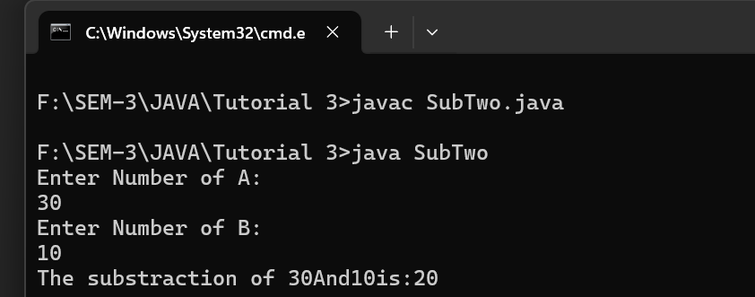

- Question 8:Write a program to multiply two float values and print the result.
public class Mul {

public static void main(String[] args) {

float number1 = 15.7f;
float number2 = 3.2f;

float product = number1 * number2;
System.out.println("The product of " + number1 + " and " + number2 + " is: " + product);
} }
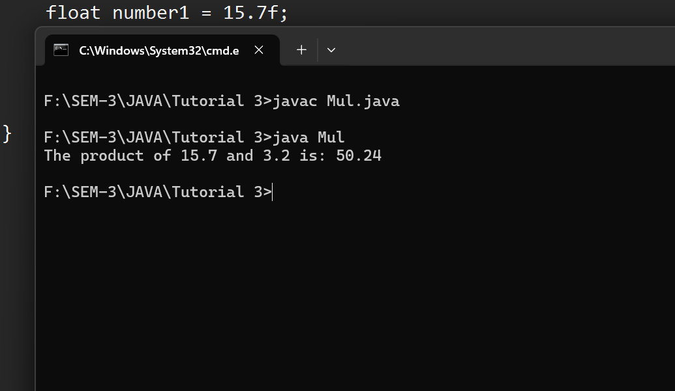
- Question 9:Write a program to divide two integer values and print the result.
public class Division {
public static void main(String[] args) {

int dividend = 25;
int divisor = 5;
if (divisor == 0) {
System.out.println("Error: Cannot divide by zero.");
} else {
int result = dividend / divisor;
System.out.println("The result of " + dividend + " divided by " + divisor + " is: " + result);
}
}
}
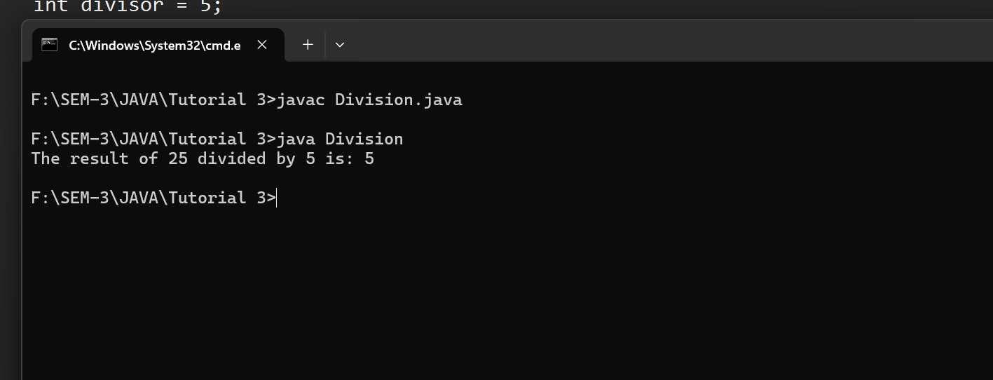
- Question 10:Write a program to find and print the remainder of two integers.
public class Remainder {

public static void main(String[] args) {

int dividend = 25;
int divisor = 4;

int remainder = dividend % divisor;

System.out.println("The dividend is: " + dividend);
System.out.println("The divisor is: " + divisor);
System.out.println("The remainder is: " + remainder);
}
}